**KING’S COLLEGE – BUDDO**

**UGANDA CERTIFICATE OF EDUCATION**

**INTERNAL MOCKS EXAMINATIONS 2020**

**GEOGRAPHY**

**PAPER 273/2**

**Time: 2hours**

**Instructions;**

* Answer four questions only
* Choose two questions from part 1 and two from part II
* In part II, only one question should be chosen from any one region
* Any additional question(s) answered will not be marked.

**PART 1: REST OF AFRICA: Answer Two questions in this part**

1. (a) Draw a sketch map of Africa and onto it mark and name areas which receive mean Annual Rainfall of;-
2. Less than 500mm
3. Over 2000 mm
4. 1000 – 2000mm ***(07 marks)***

(b) Describe the factors which have led to;-

1. Mean annual rainfall of over 1500mm ***(05 marks)***
2. Mean annual rainfall of less than 500mm ***(05 marks)***

(c) Explain the influence of rainfall on human activities carried out in (a) above. ***(05 marks)***

(d) State the negative effects of rainfall in areas in (a) (i) above.

***(03 marks)***

1. Study table showing land area order permanent crops.

|  |  |
| --- | --- |
| **Country** | **Land area 000/s acres** |
| D.R.C | 6,700 |
| Ethiopia | 10,000 |
| Nigeria | 28,200 |
| Swaziland | 178 |
| Zambia | 5,260 |
| Total | 50,338 |

1. Draw a pie chart to show the relative importance of land area under permanent crops. ***(08 marks)***
2. State the country with;-
3. Largest
4. Smallest

Area of land under permanent crop. ***(02 marks)***

1. (i) Name two crops grown in (b) (i) above. ***(02 marks)***

(ii) Describe the physical conditions that have favoured the growth of the crops identified in (c) (i) above. ***(05 marks)***

1. Explain the benefits of keeping land under permanent crops.

***(08 marks)***

1. a) Draw a sketch map of Egypt and on it mark and name ;
2. Nile delta
3. Towns : Port Said, Asyut and Cairo
4. Quattara depression
5. Areas with a population density of less than three people per km2. ***(07 marks)***

b) i) Define population density. ***(02 marks)***

ii) Describe the factors which have led to a low population density in the areas marked on the map. ***(06 marks)***

c) Outline the problems faced by people living in sparsely populated areas in Egypt. ***(05 marks)***

d) Outline the measures being taken to address the challenges in © above. ***(05 marks)***

1. Study fig. 1, Map of Nigeria showing Kainji dam and answer the questions that follow.

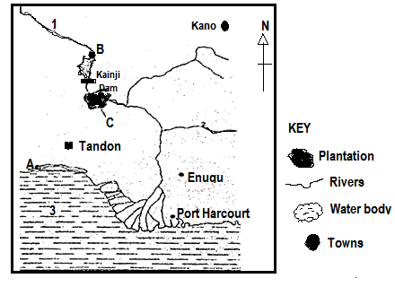

1. Name the ;
2. Rivers marked 1 and 2
3. Water body marked 3
4. Towns marked A and B
5. Plantation crop grown in area marked C ***(05 marks)***
6. Describe the conditions which have favoured the location of Kainji dam. ***(08 marks)***
7. Explain the problems caused by the establishment of Kainji dam. ***(06 marks)***
8. Outline the contribution of the dam to the development of Nigeria. ***(05 marks)***

**PART II: STUDIES IN DEVELOPMENT**

**REGION 1: NORTH AMERICA: Attempt one question**

1. a) What are the aims for the construction of the St. Lawrence sea way? (**05 marks)**

b) Explain the shipping hazards that existed along the sea way.

***(10 marks)***

c) State the steps that were taken to overcome the shipping hazards along the sea way? ***(05 marks)***

d) How did U.S.A and Canada benefit from construction of the sea way? ***(05 marks)***

1. a) Draw a sketch map of New England and on it mark and name ;
2. states : Maine , Rhode Islands and New Hampshire
3. towns : Boston and New port
4. tobacco and fruit growing region ***(08 marks)***

b) Describe the physical factors favouring arable farming in New England. ***(06 marks)***

c) State the problems facing farmers in New England. (***06 marks)***

d) What changes have been taken to improve agriculture in the New England region of U.S.A.

1. Draw a sketch map of the Tennessee valley and onto it mark and name;
2. towns : Nashville and Memphis
3. states : Kentucky and Tennessee
4. Rivers : Cumberland and Ohio
5. Dams : Pickwick and Kentucky ***(08 marks)***

b) Explain the conditions which necessitated the establishment of the Tennessee Valley Authority project. ***(06 marks)***

c) State the changes that were made to improve the Tennessee area. ***(06 marks***

d) What were the effects of the project in the Tennessee area?

***(05 marks)* REGION II: RHINE LANDS**

***Choose one question***

1. Study table showing irrigated areas in Rhine lands.

|  |  |
| --- | --- |
| **Country** | **Percentage of irrigated land** |
| Belgium | 30 |
| Germany | 04 |
| Netherlands | 60 |
| Switzerland | 06 |

1. i) State the

* least
* most

Country with irrigated land. ***(02 marks)***

ii) Draw a pie-chart showing the relative importance of irrigated land.

(**07 marks)**

b) Describe the factors that have favoured irrigation in the Rhine lands countries. ***(08 marks)***

c) State the problems resulting from irrigation farming. **(*04 marks)***

d) What steps are being taken to improve irrigation farming?

***(04 mark)***

1. **Studyfigure; Sketch map of the Ruhr Coal field and answer questions that follow;.**

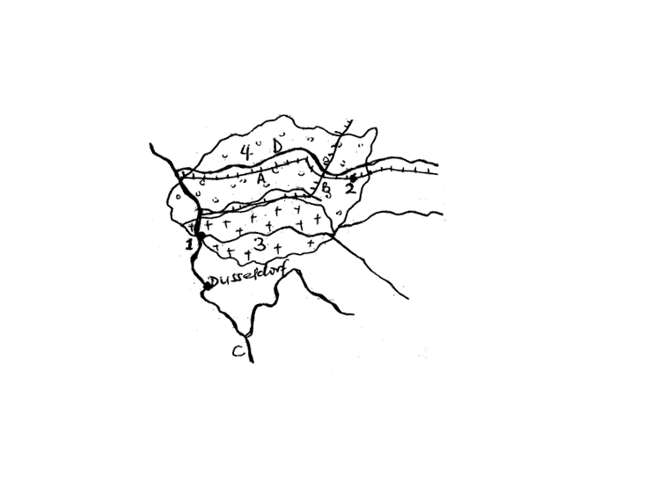

Name;

1. Town 1 and 2
2. Canada A and B
3. Rivers C and D
4. Coal fields 3 and 4. ***(08 marks)***

b) Describe the factors that have favoured coal mining in the Ruhr region. ***(06 marks)***

c) Why is there a decline in coal mining in the Ruhr region?***(06 marks)***

(d) State the effects of Coal mining on the environment. ***(05 marks)***

1. Study the sketch map of Belgium and answer questions that follow.

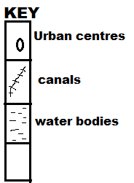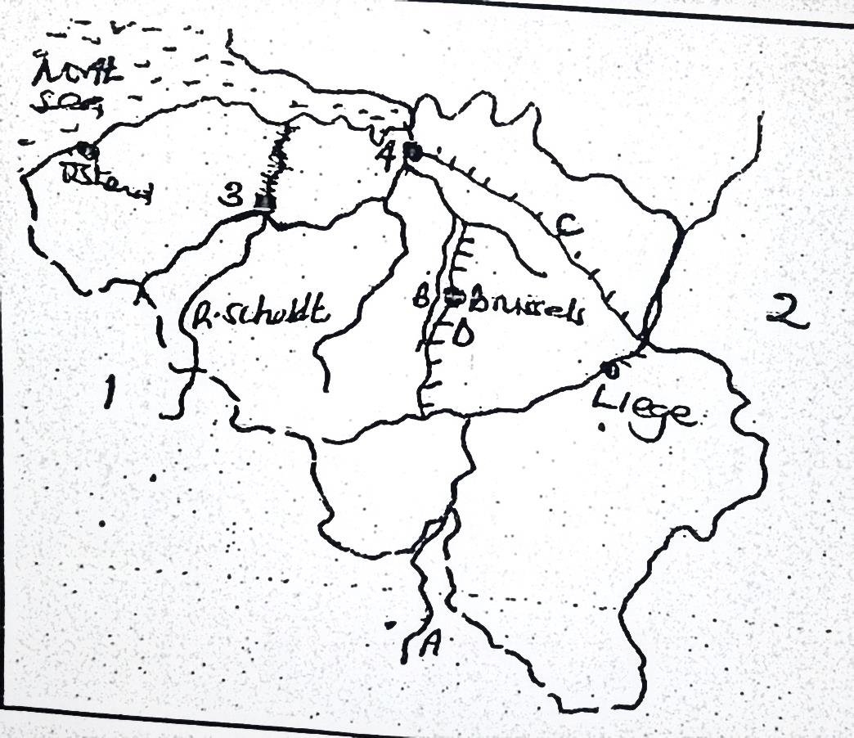

Name ;

1. Rivers A and B
2. Countries 1 and 2
3. Canal C and D
4. Urban centres 3 and 4 ***(08 marks)***

b) Giving the specific examples, explain factors for growth of urban centres in Belgium. ***(06 marks)***

c) State the negative effects of urban growth on the environment in Belgium. ***(05 marks)***

d) What steps are being taken to improve urban centres in Belgium?

***(06 marks)***

**END**